DS 5110

Final Project Report

Dylan Weinmann and Kenneth Aldridge

**Introduction:**

Our Database system is an Art Museum Database. The system is intended to keep track of the museum’s art pieces, visitors, and employees. For each art piece, the system will store information about the art piece, its artist, and the exhibit it is located in. For each employee, the system will store their hours worked, their salary, and their department. For each visitor, the database will keep track of their visit time, who checked them in, their ticket for entering the museum, and if they had a reservation or not. The overall objective of the database is to keep information about the daily activity and the art stored in the museum.

**Database Design:**

This is our final ERD:

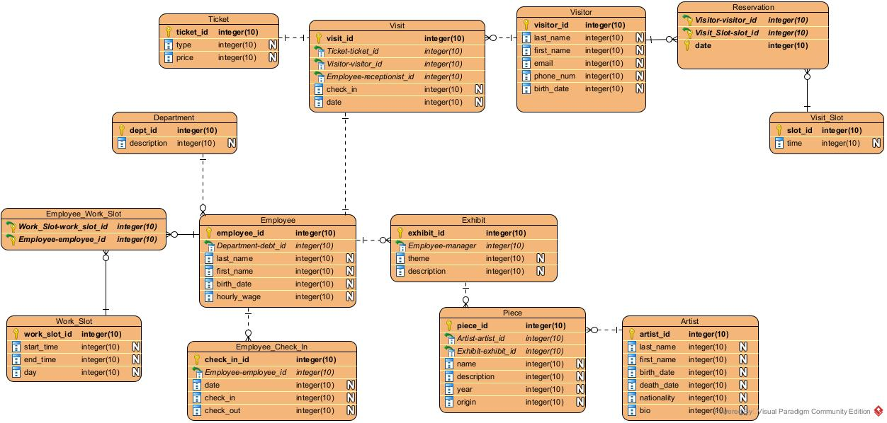

Overall, the design of the database is simple, storing information about employees, art pieces, and visitors. There were some key design choices, though. One of them was creating the ability for visitors to have a reservation that is connected to a visit slot (which offers one hour blocks from 10 am to 7 pm). Another was connecting the action of a visit to the purchasing of a ticket, which allows for the tracking of how much money is being collected by the museum. We also decided to have the database be able to track employees’ working hours and when they check in/out each day, offering the database the ability to see who is late or not and track daily employee work. Having the art pieces connected to an exhibit is important as well, because museums display their art pieces in different exhibits and tracking where each art piece is important. All the data was normalized naturally, as each table has a primary key and most tables have foreign keys, so each dependency relies on the primary key of the table, making it at least normalized to BCNF.

**Data Collection:**

We did collect data from any source or take it from the internet, instead making it up. We tried to make the data somewhat realistic, for example every artist does not have a death date and the time slots that employees work in are in the ranges of 8 am to 6 pm. Even for the artists and art pieces, we did not use real people and real artworks, rather we just made it up and manually inputted the data into the database like the rest of our project. Since the data was made up, there were no necessary cleaning up or pre-processing steps.

**Application Description:**

The application uses the command line to prompt, display, and receive information from the user. It allows the user to run stored procedures, run any number of preset queries, and update, delete, and insert to the database. The application uses the mysql.connector library to connect to the database. It uses parameterized queries to protect the safety of the database when asking the user for input. All user input is either a single character to navigate or database information for input and retrieval.

**Conclusions/Future Directions:**

We have learned a lot from this project, namely even for a simple database such as ours, there are a lot of different aspects to consider. For example, something as simple as representing which hours employees work there had to be two tables created so that the database can operate in the most efficient way. Further, when thinking about the reservation system, it took us a while to come up with the best way to develop relationships between the visitor, reservation, visit_slot, ticket, and visit tables. We have learned that designing a real database that represents an actual system and actual data is challenging and it is time consuming to brainstorm the best way to represent relationships between sets of data in a relational database.

If we had more time to spend on the project, we probably would have fleshed out the data we made up a bit more, for example potentially altering the salaries based on what department the employees are in or having artists stick to one or two types of artwork. While we tried to make our data realistic, it was difficult and time consuming to come up with enough data to fill up 10 rows in each table, so the data is not perfect. With more time, it would have been better to make it even more realistic. We would have also developed more functionality for having special exhibits, as art museums sometimes have limited-time exhibits, and we would have created a way to track which exhibits each visitor goes to.

The most important advice we would give to future DS 5110 students about the final project is to start early as we did not realize how long it takes to simply just come up with a functional idea for the database. Then, planning out the schema of the database and finding/coming up with the data takes up even more time, so starting early is important. We would also tell future students to have fun with the project because it is really interesting understanding how to create and how databases actually run in a realistic scenario.

Database Schema Diagram:

